**DAILY ONLINE ACTIVITIES SUMMARY**

|  |  |  |  |  |  |  |  |  |
| --- | --- | --- | --- | --- | --- | --- | --- | --- |
| **Date:** | **20/05/202** | | | | | **Name:** | **Anjali Manohar Prabhu** | |
| **Sem & Sec** | **4th Sem Section - ‘A’** | | | | | **USN:** | **4AL18CS007** | |
| **Online Test Summary** | | | | | | | | |
| **Subject** | | **OBJECT ORIENTED CONCEPTS (18CS43)** | | | | | | |
| **Max. Marks** | | **30** | | **Score** | | | **18** | |
| **Certification Course Summary** | | | | | | | | |
| **Course** | **MACHINE LEARNING FOUNDATION** | | | | | | | |
| **Certificate Provider** | | | 1. **Great Learning Academy** | | **Duration** | | | **1.45min** |
| **Coding Challenges** | | | | | | | | |
| **Problem Statement:** 1. To find the shortest of the palindrome | | | | | | | | |
| **Status: Executed** | | | | | | | | |
| **Uploaded the report in Github** | | | | | **Yes** | | | |
| **If yes Repository name** | | | | | [**https://github.com/vinisharen/lockdown-coding**](https://github.com/vinisharen/lockdown-coding) | | | |
| **Uploaded the report in slack** | | | | | **Yes** | | | |

Online Test Details: Online test for OOC (18CS43) was scheduled from 9:30 to 10:00 AM and the syllabus for the exam was 1st module. There were 30 questions (MCQ) and the time allotted for the test was 30 min

Certification Course Details:

Bloomberg presents "Foundations of Machine Learning," a training course that was initially delivered internally to the company's software engineers as part of its "Machine Learning EDU" initiative. This course covers a wide variety of topics in machine learning and statistical modeling. The primary goal of the class is to help participants gain a deep understanding of the concepts, techniques and mathematical frameworks used by experts in machine learning. It is designed to make valuable machine learning skills more accessible to individuals with a strong math background, including software developers, experimental scientists, engineers and financial professionals.

Snapshot: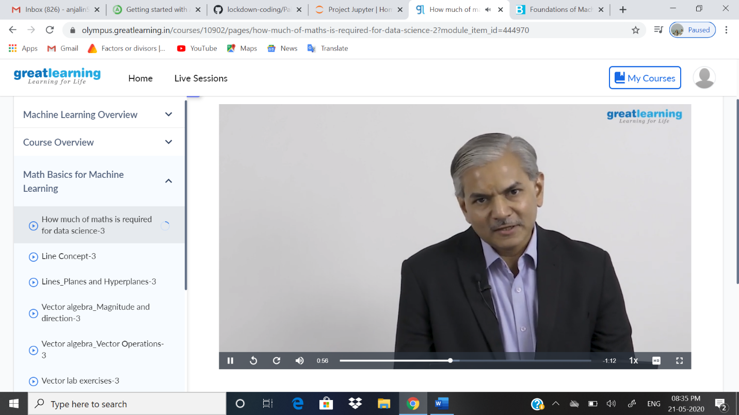

Coding Challenges Details: Problem statements: .

1. To find the shortest of the palindrome

Solution: Uploaded in github

Snapshot: